**Assignment-1**

1. **Use the installation guide,to set up your system for performing the Tableau practical. Refer to the Installation Guide in “Installation Guide – Tableau-10.0” section with the file named “Installation Guide”**

**Note: In a word document, take screenshot of the final screen of installation step and home screen of tableau and submit it.**

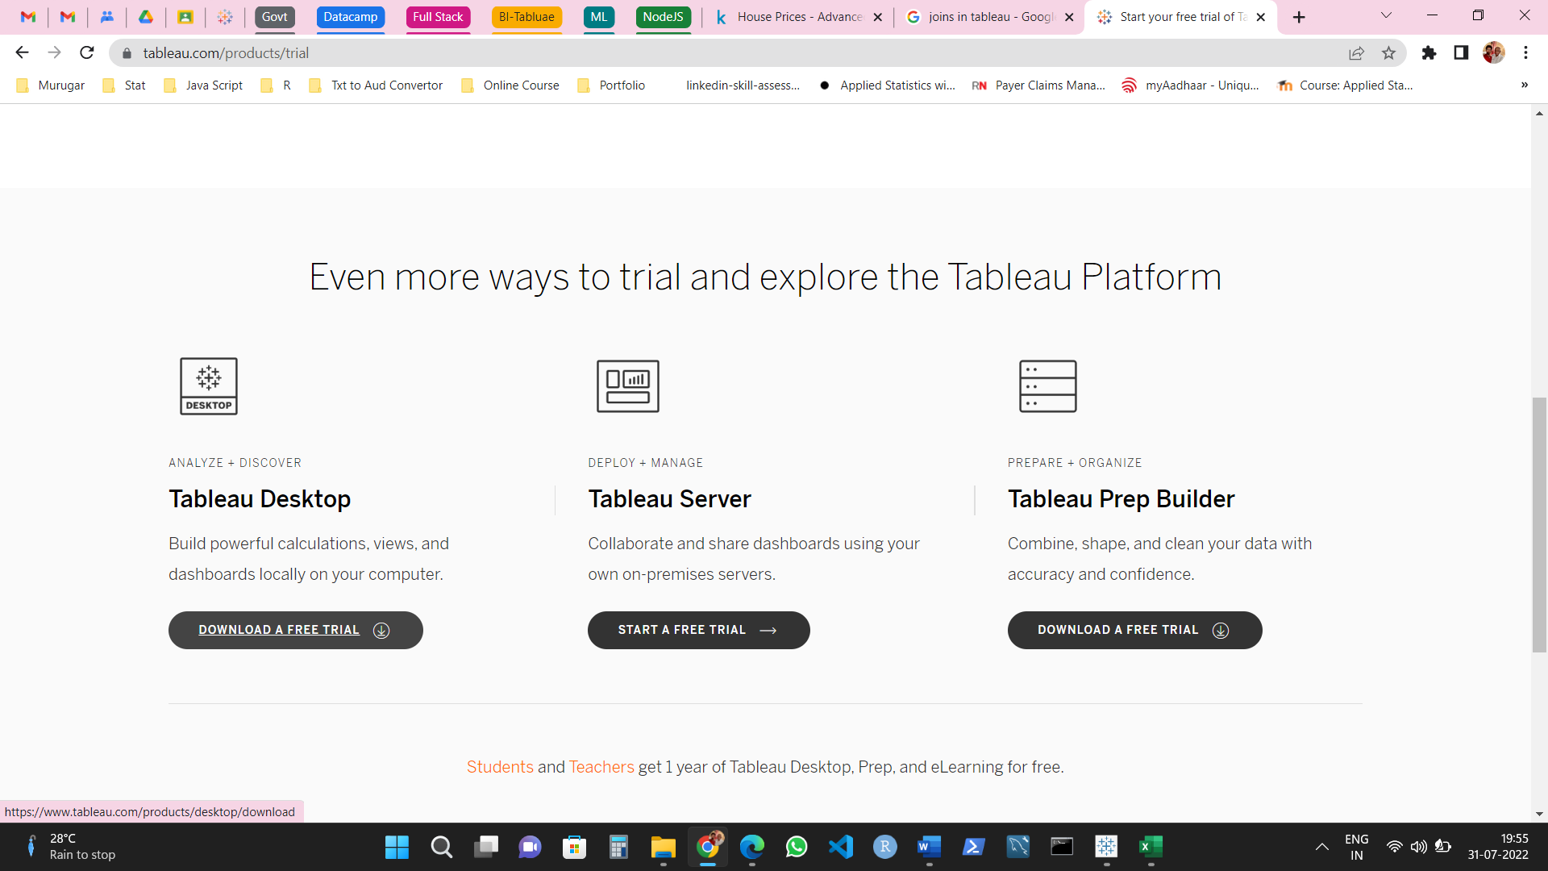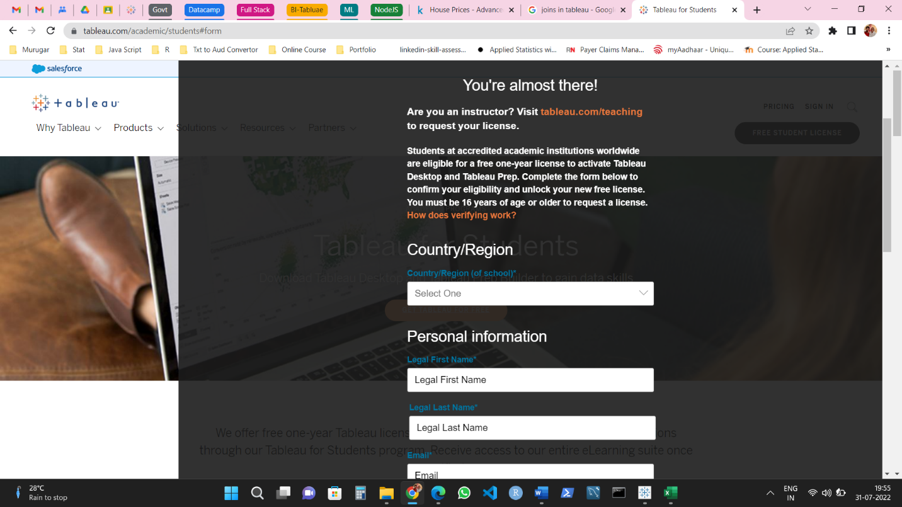

1. **Download the data – set (sales – product) from the link:**

**Establish the connection between tableau and data-set.**

**Perform left join, right join, cross joins between sales and product data-set**

**Note the difference between them joins in terms of data – set and visualization and compile them in a word document.**

**Note: In a word document, compile the screenshot of all the above tasks performed**.

